GPS-XAR Project Management Plan Draft
Response to S07-076

Delivered to:
Jane Wells
SAIC-Frederick, Inc.
92 Thomas Johnson Drive
Suite 250
Frederick, MD 21702

Prepared by:
5AM Solutions, Inc.
1625 N 11th Avenue
Phoenix, AZ 85007
Contact: Brent Gendleman
E-mail: bgendleman@5amsolutions.com
Mobile: 602-722-1530

Table of Contents
1. Introduction 1
2. Executive Management Commitment 1
3. Software Development Process 1
3.1 Process Overview 1
3.2 Disciplines 1
3.2.1 Requirements 2
3.2.2 Analysis and Design 2
3.2.3 Implementation 2
3.2.4 Test 2
3.2.5 Change and Configuration Management 2
3.2.6 Project Management 3
3.2.7 Environment 3
3.3 Phases 3
3.3.1 Inception 3
3.3.2 Elaboration 3
3.3.3 Construction 3
3.3.4 Transition 4
3.3.5 Maintenance and Support 4
4. Tools 4
4.1 MDA Approach 4
5. Schedule 5
5.1 Iteration Plans 5
5.1.1 Iteration 1 – Inception 1 5
5.1.2 Iteration 2 – Elaboration 1 6
5.1.3 Iteration 3 – Elaboration 2 6
5.1.4 Iteration 4 – Construction 1 6
5.1.5 Iteration 5 – Construction 2 7
5.1.6 Iteration 6 – Transition 1 7
5.1.7 On Going Support and Maintenance 7
6. Staffing and Roles 7
7. Control and Escalation Procedures 8

Table of Figures
Figure 1 – Proposed Coarse Grained Schedule with Deliverables 5

Introduction
This document defines the project management approach for the Genome Proteomics Standard Tool for XAR GPS-XAR GPS-XARdevelopment effort. It will evolve over the course of the project, primarily being updated at the transition point between iterations. Results of the concluding iteration, both good and bad, will be incorporated into the plan, and refinements will be made to upcoming iterations according to those same results and discoveries. This document tries not to assume that the reader is overly familiar with the Rational Unified Process (RUP), but readers are encouraged to seek additional sources that might provide further background.

Executive Management Commitment
This contract is of strategic importance to 5AM Solutions, so it will receive constant attention from senior management. In recognition of this importance, 5AM Solutions has assigned an officer of the company and experienced Project Manager (PM) responsible the overall project and its deliverables. The PM will be both aware, and make concerned parties aware, of all progress and hindrances to progress for the project. As a corporate management function, 5AM conducts weekly staff meetings during which each contract is discussed and any problems are raised along with the plan for resolution. Day-to-day monitoring of the contract tasks is the responsibility of our PM. For managing tasks, metric data is gathered and compared against the project management plan. Our PM reviews these analytical comparisons to determine whether there are any problems in executing the plan. Our PM and technical team discuss any problems and draw upon their years of experience to find solutions. The PM acts as the single point of contact for the project and controls the planning and execution of the project’s activities and resources to ensure that established cost, time, and quality goals are met.

Software Development Process
5AM boasts repeated success in the application of RUP to drive its software development. Most team members have been through multiple projects together using the RUP, and it has become second nature on all projects we undertake. Additionally, in the quest for never-ending improvement, 5AM has continually reduced the amount of overhead expended applying the RUP, and have carefully managed to incorporate several “agile” tenets to further increase productivity.

Process Overview
Our software development process, which is an implementation of the RUP, is well suited to the project as the RUP is use-case driven, architecture-centric, and iterative. Furthermore, our Glassbox Software Development (GSD) approach employs a set of tools and practices that promote the efficient development of quality software. These practices are designed to provide up-to-the-minute test and quality metrics directly to our clients as well as to the internal project team. We want to expose where we are, where we are going and what is needed to ensure we are consistently aligned (or at least have the opportunity to realign) with the evolving needs of the customer.
RUP is an iterative process through which all iterations progress through the complete set of software development disciplines from requirements through testing. The first section that follows here describes how these disciplines would be applied to the project and specifically how they relate to tasks listed in the SOW. A second key aspect of the RUP is that iterations have different emphases based on the phase of the project in which they take place. How these phases relate to this effort is described in the second subsection.
In describing our development process, we also will indicate how we are aligned with the Open Source, Open Access, and Open Development caBIG initiatives.

Disciplines
This section describes how we’ll apply the essential disciplines. Note that certain disciplines will have greater or lesser levels of effort applied to them depending on the phase of the project. For example, during the inception phase, we may see very little of the implementation discipline, but during the construction phase, we’ll see implementation maximized.

Requirements
The high-level requirements are given in the SOW. Over the course of the inception, we will determine the key stakeholders, and work with them to refine these requirements into specific, testable requirements. Functional requirements will be captured in use case documentation and non-functional requirements and design constraints will be captured in the requirements document as described in the SOW.
In addition to recording requirements content in the aforementioned documentation, requirements attributes, status, and approval will be managed through NCICB’s GForge Tracker so that project stakeholders may review requirements definitions and progress at will. Furthermore the GForge Tracker web interface facilitates on-line, recorded discussion of specific requirements issues.

Analysis and Design
Rather than using UML to retroactively document a system, our approach to software engineering is based around using UML to visualize component architectures prior to implementation. Generally speaking, structural diagrams are used to define components, their interrelationships, and their internal parts. Behavioral diagrams are employed to define how these components collaborate to provide the required functionality and also are used to define their internal behavior. This approach leads to a more robust and maintainable architecture and ensures that all requirements are met.
The architectural views contained within the design model are captured in a Software Architecture Document, which is augmented with additional content to explain the architectural design decisions. The architecture is documented from several perspectives: the use-case, logical, implementation, process, and deployment views.

Implementation
Implementation is nothing more than a big-city word for coding. During implementation in any one iteration, developers will focus on meeting the needs of the iteration, while at the same time working to fully develop components and their associated automated tests (i.e. various types of tests including unit, component, system, functional and performance to name a few) so that they can be fully assessed for their sufficiency and completeness. Implementation will be supported with a completely automated and comprehensive build process, one that incorporates automated build and test facilities. We will rely on continuous integration to ensure those assets that are checked into the SCM will build and interoperate with those assets already in the SCM. In accordance with the Open Source initiative, all implementation artifacts will be released under the open-source license designated by the NCICB.

Test
A substantial value specified by agile processes, composing tests *prior* to implementation (Test Driven Development) is a critical mindset that serves to improve the quality of class and component design. Additionally, as noted in the implementation description, test preparation and coverage analysis will further our confidence in the reliability of the software and success of our continuously integrated builds. At the system and functional testing level, we will employ automated testing to the greatest extent possible to shorten the development feedback cycle and to allow for easy, repeated regression testing. All implemented functionality requires a directly proportional amount of energy devoted to testing.

Change and Configuration Management
In order to allow for flexibility and the inevitability of change while still adhering to schedule, we recommend agreement upon a change management process. We recommend that, at key milestones, important artifacts undergo baseline, such as the requirement set and the software architecture. Prior to baseline, these artifacts undergo considerable change, but afterwards they can only be changed upon the agreement of a Change Control Board (CCB). The CCB would be composed of representatives from NCICB, SAIC-Frederick, and 5AM. The CCB need not be entirely formal – it may be that CCB approval is handled by phone and email – but nevertheless this provides a framework for change while reducing the risk of schedule slippage.
In accordance with the caBIG Open Access initiative we will use the NCICB repository for configuration management, and it, in turn, will be linked to the caArray GForge project for public visibility and potential participation. We heartily endorse a move to Subversion from cvs, as Subversion is much better suited to support the branched development required to manage open development community contributions to the code base but will following the NCICB guidelines for using cvs at the time of this proposal. Our configuration management techniques follow industry proven SCM patterns.
Finally, in support of the Open Development Initiative, we will place a great deal of emphasis on this discipline and are providing specific expertise to augment the development team.

Project Management
The Project Manager is responsible for providing overall project direction, supervision, and leadership to this project. The PM works closely with the GPS-XAR Technical and Program Leads and the General Contractor to keep them informed of any deviations outside of established limits of the task baseline and discusses corrective actions. The PM has direct access to the corporate officers of 5AM Solutions and in this case, is one as well. The PM’s role is that of a line manager, who plans, organizes, assigns, monitors, reviews, controls, and reports the project’s performance.
The PM exercises day-to-day control over work performed by the 5AM Solutions team and serves as the principal interface with our project staff and the customer. The PM deals directly with the 5AM Solutions corporate staff, ensuring that the project receives appropriate administrative support and has access to all needed resources. The PM is the technical manager responsible for overall contract performance in the areas of cost, schedule, technical, management, and quality performance. Two aspects related to our implementation of the RUP are highlighted here.
- Our focus on risk management provides a strong implementation of RUP’s risk-driven approach to software development.
- Our approach to task assignment and tracking makes use of GForge’s Task features. We will directly maintain the state of the effort in GForge, which will permit NCICB and SAIC-Frederick stakeholders to review the current status of all activities at will.

Environment
The Environment discipline encompasses two major areas: first, the configurations of the software development process, and second, the set up and maintenance of the tools and systems required to develop and test the software being developed. Again, we will be targeting specific resources to support this activity independent of the primary developers.

Phases
There are four phases of a traditional RUP lifecycle: Inception, Elaboration, Construction and Transition. We will tailor the traditional RUP lifecycle to include an additional phase of Maintenance and Support

Inception
Inception is the earliest phase, where the project is scoped and stakeholder buy-in is sought. Requirements are specified to a level of detail so that stakeholders can come to agreement on scope. Additionally, several long-range planning activities take place, including environment and iteration planning for all iterations. A successful inception iteration results in all stakeholders having as near an identical vision of what is being built as possible.

Elaboration
Elaboration is the second phase, where the envisioned architecture of the finished system is implemented sufficiently that it can be executed and objectively measured, thereby providing a high level of confidence that there will be no major “surprises” once the entire development team puts their heads down. A successful elaboration phase results in an executable architecture and a reduction/mitigation/elimination of all significant architectural risks to the project.

Construction
Construction is the most labor-intensive phase, where we’ll see the largest staff size and the most code being churned out, preferably based on patterns and guidelines established during the elaboration phase. A successful construction phase will result in a complete product that is ready to be deployed to the user community.

Transition
Transition, the fourth and final phase is also the most exposed, where the user community will progressively be exposed to and utilize the system being developed. The Transition Phase includes testing the product in preparation for release, and making minor adjustments based on user feedback. At this point in the lifecycle, user feedback should focus mainly on fine tuning the product, configuring, installing and usability issues

Maintenance and Support
While not an explicit phase in the RUP, this phase is being introduced here to meet the need of on-going support for the release along with additional requests that will be prioritized and met by our team. As all the documents are living, many of the previous deliverables will be touched when particular activities occur, such as user interface changes, bug fixes and enhancements, and the truly challenging aspect of rolling externally produced code into the product code base.

Tools
5AM’s standard project management methodology includes the use of various software packages to assist the planning, monitoring, controlling, and reporting of the work efforts. We will use the environments and services provided by SAIC-Frederick and NCICB, most notably cvs for SCM and GForge as a portal to support and encourage the Open Development and Open Access initiatives. The tools and sites will be familiar to the team as a result of our current responsibilities developing caArray 1.4 and releasing 1.5 and our previous release of caAMEL. A brief summary of our toolset is provided below:
- Enterprise Architect – UML modeling tool used for design and to drive MDA implementation.
- AndroMDA – Open source Model Driven Architecture (MDA) code generation framework.
- Eclipse –Java IDE used for implementation.
- Ant – Automated build system used to compile the system and to automate packaging, unit testing and other recurring tasks.
- JUnit – Class and component-level unit testing framework.
- Clover – Provides code coverage feedback for unit tests.
- Checkstyle – Analyzes Java source code to ensure adherence to coding standards and proper coding practices.
- PMD – Analyzes Java source code to ensure proper coding practices, providing a deeper analysis than provided by Checkstyle.
- JDepend – Analyzes Java source code and reports package dependency and object-oriented design quality metrics.
- Simian – Analyzes Java source code to locate duplicated code for potential re-factoring.
- Selenium –Browser-based test automation tool for functional testing.
- CruiseControl – Continuous integration system used to provide constant, near real-time feedback on the quality of the code base.
- CVS – Source code management system.

MDA Approach
MDA is an implementation approach that takes a technology-independent object model and transforms it via automation into an implementation based on a specific technical approach. As indicated in the Organizational Qualifications section of our Technical Proposal, we have been successful at applying MDA to rapidly implement functionality based on MAGE-OM. We will leverage our existing artifacts and experience when designing transformations for GPS-XAR. Recent advances in MDA tools will add to the efficiency. Also, an MDA approach allows for potentially reducing the effort for registration of the GPS-XAR into caDSR.

Schedule
The schedule is both iterative and incremental. The schedule is broken into a series of iterations, each one resembling a miniature waterfall lifecycle composed of traditional disciplines, including requirements analysis, design, coding, and test. Not all iterations will result in a deployable work product, though each one should provide us with objective and measurable results, which in turn can be used to further refine future iterations. Successive iterations will add more and more features to the work product, so that macroscopically, we will see incremental growth of the deployable features of the system. The scope for GPS-XAR is of premium importance as we know we have the skills to perform the job. The question will be what gets into the release and what does not, which will determine when the release occurs. It is also vital that the user community knows what to expect and when so that the beta release is optimized for testing and we can remain highly productive and interactive during that month. Our initial schedule is proposed below.
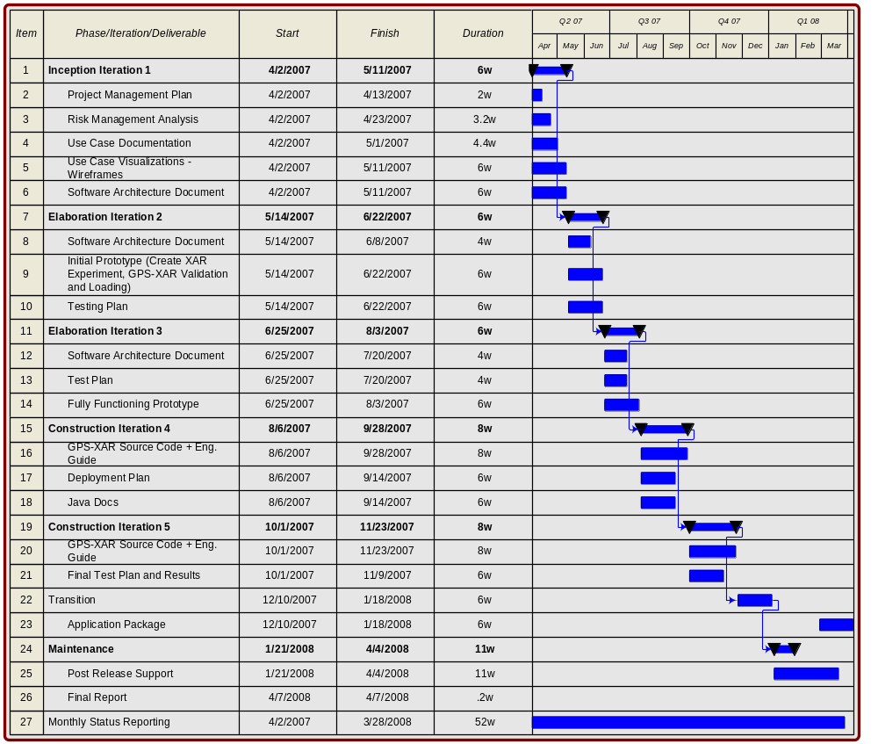
Figure 1 – Proposed Coarse Grained Schedule with Deliverables

Iteration Plans

Iteration 1 – Inception 1
In this iteration, we will organize and analyze the GPS-XAR requirements and determine the significant architectural risks to be mitigated. Finally, we will develop the initial draft of the test plan in this iteration.

Deliverables
- “Final” Project Management Plan –Within the first 10 days of the project a complete project schedule will be delivered that integrates and expands the Deliverables Schedule shown in Figure 1.
- Initial Use Case Model with User Interface Wireframes to support applicable Use Cases (such as the Create Annotated Proteomic Experiment XAR file).
- Draft Candidate Architecture Document
Additional artifacts to be created and updated in this iteration include the use-case model, use-case and supplementary requirements specifications, test plan, and the project risk list. We will also create the data model and initial UML design model in this iteration – much of the content in the database architecture and design document deliverable will be extracted from these models.

Iteration 2 – Elaboration 1
During this initial Elaboration Iteration, we will begin testing our approach to the prioritized features, critical architectural elements and issues uncovered during Inception. Updates to the previous three deliverables will occur, along with some effort expended toward those in the future. Key artifacts from this iteration include an executable architectural prototype, an updated UML design model, and an updated Software Architecture Document.

Deliverables
- Completed Risk Management and Use Case Documents
- Updated Software Architecture Document
- Initial Framework for the GPS-XAR module

Iteration 3 – Elaboration 2
The blueprint of GPS-XAR will be delivered here. The approach to creating, validating and parsing XAR files will be designed and implemented. Test cases will be developed and automated for all requirements implemented thus far and the process and implementation for creating additional automated test cases will be available for future requirements to be implemented in the Construction iterations.
In addition, further attention to user interface enhancements will be investigated here, though likely implemented in Construction.

Deliverables
- Complete Software Architecture Document (will continue to be maintained post this iteration but its formal submission will occur here)
  - Full UML documentation will be made available here
- Testing Plan

Iteration 4 – Construction 1
As mentioned earlier, this is likely to be where our team size grows to be the largest. The implementation of the accepted architecture will be done here with the focus of developing a sustainable, maintainable Beta Release. We may want to do an alpha build with one or more chosen early adopters to validate beyond the realm of the NCICB environment.

Deliverables
- Deliver database and loader implementation
  - Database Build Components – The components required to build the database on a deployment host. This includes data definition language files that define the structure of the tables, scripts that define the logic of the stored procedures and a script that integrates all these together into a database. Furthermore, scripts and data required to load pre-populated tables are included here.
  - Software Build Components – The components required to build the executable system on one or more deployment hosts. This includes HTML/Script files and their associated image files required for the front-end, plus software components and their deployment descriptors that comprise the middle tier. Scripts and other configuration files required to build the system are also included.
  - Integrated, Deployed Build – In addition to providing all the pieces required for building the system, a final deliverable is the complete system deployed on a client machine. In fact, a number of integrated builds will be demonstrated within the development environment culminating in an integrated, deployed build on the target environments.

Iteration 5 – Construction 2
The significant milestone from this iteration is the Beta Release. It will be a stable, executable version of GPS-XAR, together with all artifacts necessary to use this release. It is understood that once this release is shared with the cancer centers, they will have one month to test.
Deliverables:
- Beta release of GPS-XAR source code and a compiled package with software engineering guide
All in-scope requirements, performance requirements and associated deliverables are available and verified in their completeness.

Iteration 6 – Transition 1
During the month of acceptance testing by the NCICB and the programs designated adopters, we will fix any defects found and update release documentation in preparation for final release.

Deliverables
- Deployment Plan
- Complete Java Documentation
- Final System Test Plan and Results

On Going Support and Maintenance
While no deliverables are directly identified in the SOW, we expect to perform the following activities following the final release of GPS-XAR:
- Defect Fixes, User Interface Enhancements, Additional Features
- Support the Open Development Initiative
- Support caBIG’s Integrative Cancer Research workspace
We expect that once the current issues are addressed, additional features will be requested and warrant attention.

Staffing and Roles
Following the core disciplines and typical RUP lifecycle, the team will start fairly small (2), peak during the height of implementation (perhaps 4), and then decline again following successful transition into on-going support (2). Table 2 below identifies the team members, their role(s), and anticipated utilization for all iterations. Key personnel are denoted with an “*”.

Core Role | Role Description | Proposed Key Personnel
Project Manager | The project manager role allocates resources, shapes priorities, coordinates interactions with customers and users, and generally keeps the project team focused on the right goal. The project manager also establishes a set of practices that ensure the integrity and quality of project artifacts.  The typical RUP role of Deployment Manager is also rolled in, meaning they are responsible for planning the product's transition to the user community, ensuring those plans are enacted appropriately, managing issues and monitoring progress. | Brent Gendleman
Software Architect | The software architect role leads and coordinates technical activities and artifacts throughout the project. The software architect establishes the overall structure for each architectural view: the decomposition of the view, the grouping of elements, and the interfaces between these major groupings. Therefore, in contrast to the other roles, the software architect's view is one of breadth as opposed to one of depth. | Krishna M. Kanchinadam* with support from Eric Tavela (architecture) and Rob Daly (modeling)
Requirements Analyst | The system analyst role leads and coordinates requirements elicitation and use-case modeling by outlining the system's functionality and delimiting the system; for example, establishing what actors and use cases exist, and how they interact. | Brent Gendleman
User Interface Designer | The user-interface designer leads and coordinates the prototyping and design of the user interface, by:  -- capturing requirements on the user interface, including usability requirements  -- building user-interface prototypes involving other stakeholders of the user interface, such as end-users, in usability reviews and use testing sessions. | Brent Gendleman
Database Designer (Information Layer Lead) | The database designer role defines the tables, indexes, views, constraints, triggers, stored procedures, tablespaces or storage parameters, and other database-specific constructs needed to store, retrieve, and delete persistent objects. This information is maintained in the Data Model. | Krishna M. Kanchinadam with support from Scott Miller
Designer/Developer (Presentation Layer Lead, Business Layer Lead) | The designer/developer role defines the responsibilities, operations, attributes, and relationships of one or several classes, and determines how they will be adjusted to the implementation environment. In addition, they may have responsibility for one or more design packages, or design subsystems, including any classes owned by the packages or subsystems. They are responsible for developing and testing components, in accordance with the adopted standards of the project, for integration into larger subsystems. When test components, such as drivers or stubs, must be created to support testing, the implementer is also responsible for developing and testing the test components and corresponding subsystems. | Krishna M. Kanchinadam*, Scott Miller
Test Manager/ Designer/Tester | A composite role suitable for smaller projects, this combines three RUP roles:  Responsible for the overall test effort’s success.  Responsible for defining the test approach and ensuring its successful implementation. The role involves identifying the appropriate techniques, tools and guidelines to implement the required tests, and to give guidance on the corresponding resources requirements for the test effort. The role involves quality and test advocacy, resource planning and management, and resolution of issues that impede the test effort.  Responsible for identifying and defining the required tests, monitoring detailed testing progress and results in each test cycle and evaluating the overall quality experienced as a result of testing activities. The role typically carries the responsibility for appropriately representing the needs of stakeholders that do not have direct or regular representation on the project.  Responsible for conducting the necessary tests and logging the outcomes of that testing. | Scott Miller with support from Steve Matyas
Configuration Manager | The Configuration Manager role is responsible for providing the overall Configuration Management (CM) infrastructure and environment to the product development team. | Krishna M. Kanchinadam
Environment Lead | Responsible for the development environment on the project. This includes establishing tools and their usage policies, as well as ensuring development and integration environments function effectively for the rest of the development team. | Steve Matyas*
Product Documentation Specialist | The Product Documentation Specialist role is responsible for producing end-user support material such as user guides, help texts, release notes, in addition to ensuring all deliverable documentation convey concepts appropriately and efficiently for their intended audiences. | Krishna M. Kanchinadam with support from Brent Gendleman
Table 2 – Team Roles, Descriptions and Proposed Personnel

Control and Escalation Procedures
In an ideal world projects are undertaken in an environment of total certainty. Every decision is made with total knowledge of the variables and all data required to make a decision is readily available, and the outcome can be predicted with a high degree of confidence. In reality, most decision are made without complete or near complete data, and therefore gives rise to some degree of uncertainty in the outcome. The goals of risk management, therefore, are to identify project risks and develop strategies which either significantly reduce them or take steps to avoid them while at the same time taking steps to maximize associated opportunities. Risk Management consists of an iterative set of procedures and techniques that are used to identify, control, assess, and report risk. The risk management activity is an integral part of the 5AM Solutions project management methodology for project planning and control.
It is during the Inception phase of the project where the greatest degree of uncertainty resides and where directions taken at this point in the project have the greatest influence on the outcome of the project. During this phase 5AM Solutions will perform risk identification and create the initial risk matrix. While not identified as a deliverable in the RFP, this is essential to overall success. We will use the Tracker Functionality in GForge to expose identified risks, track them through the project and indicate strategies for mitigation along with their conclusion.

Software Configuration Management Patterns: Effective Teamwork, Practical Integration by Steve Berczuk with Brad Appleton.

